Models of grief/loss
Phases or Stages of Grief Models  Kubler Ross Denial Anger Bargaining Depression Acceptance Worden’s Tasks of Mourning 1. Accept Reality of loss 2. Process Pain of loss  Murray Parkes Shock Separation/pain Despair Acceptance Re-organisation 3. Adjust to world without deceased 4. Find Enduring Connection (whilst living) | Dual Processing Model  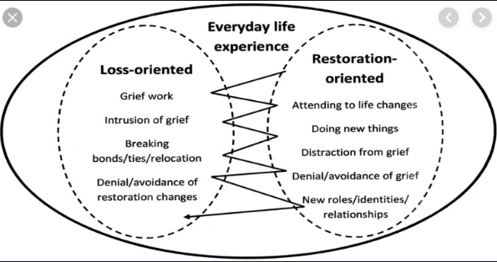
Tonkin’s Fried Egg Model  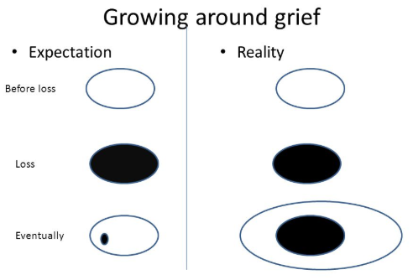 | Continuing Bonds  Grief isn’t about severing bonds with the deceased (Freud), those bonds always exist and change over time like they did during their lifetime.  Bereavement is about nurturing those bonds and connecting with the deceased

